Your supermarket company has a simple web service built on nginx that serves a static list of fresh fruit available in their stores. They want to run this service as a Docker container in their new swarm environment, but first they need you to build a Docker image for this service.

On this repo (https://github.com/satyensingh/full-docker-training-16-Z-Assignment1.git), you will find the files needed to create the image. Create a Dockerfile to define the image according to the provided specifications, then test the image by running a container in detached mode and verifying that you can access the fresh fruit data from the application.

The image should meet the following specifications:

**1. Use nginx tag 1.15.8 as the base image.**

**2. Add the static fresh fruit data to the image so that it will be served by the nginx server. The data file is located on the server at static/fruit.json under the project directory. Add this file to the image at the location /usr/share/nginx/html/fruit.json.**

**3. Add the nginx configuration file. This file is located on the server in the project directory and is called nginx.conf. Add this file to the image at /etc/nginx/nginx.conf.**

**4. The image should expose port 80.**

**5. Use the following as the default command: nginx -g daemon off;.**

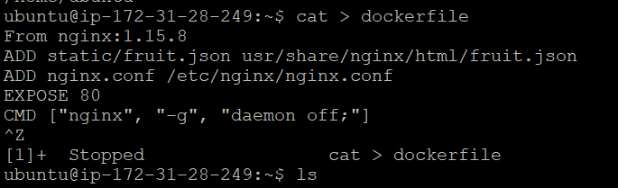

**6. Build the image with the tag fruit-list:1.0.0** 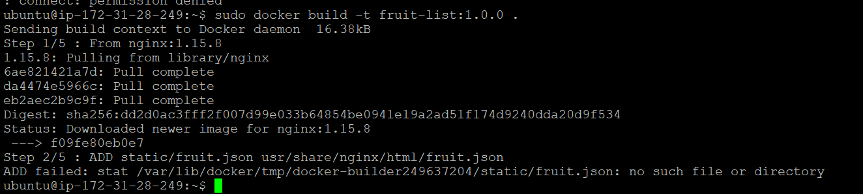

Once you have built the image you should be able to test it by running it as a container:

docker run --name fruit-list -d -p 8080:80 fruit-list:1.0.0

Verify that the container serves the required data by making a request to it on port 8080. If everything is set up correctly, you should get a JSON list of fruits.

curl localhost:8080

[NOTE: Write the series of commands to achieve above in this file below the question scenario with documentation]

Good luck!